Terraform Task-2

Task Description:

Create 2 EC2 instances on 2 different regions and install nginx using terraform script.

Techstacks needs to be used :

- AWS EC2
- Terraform
- AWS CLI

How do I submit my work?

- Push all your work files to GitHub (Code & O/P screenshot images must).
- Submit your URLs in the portal.

Terms and Conditions?
- You agree to not share this confidential document with anyone.
- You agree to open-source your code (it may even look good on your profile!). Do not mention our company’s name anywhere in the code.
- We will never use your source code under any circumstances for any commercial purposes; this is just a basic assessment task.
NOTE: Any violation of Terms and conditions is strictly prohibited. You are bound to adhere to it.

- Prerequisites
  - AWS CLI Configuration - verify AWS CLI Installation
- 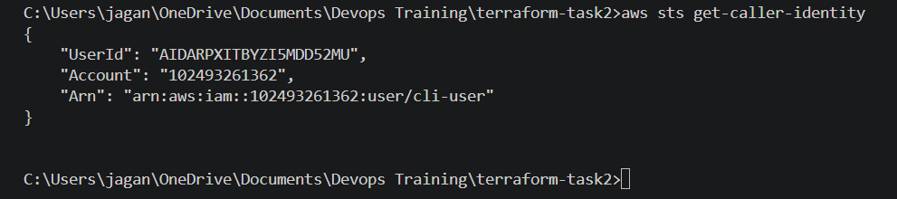

2. Terraform Configuration Files
- providers.tf
  - 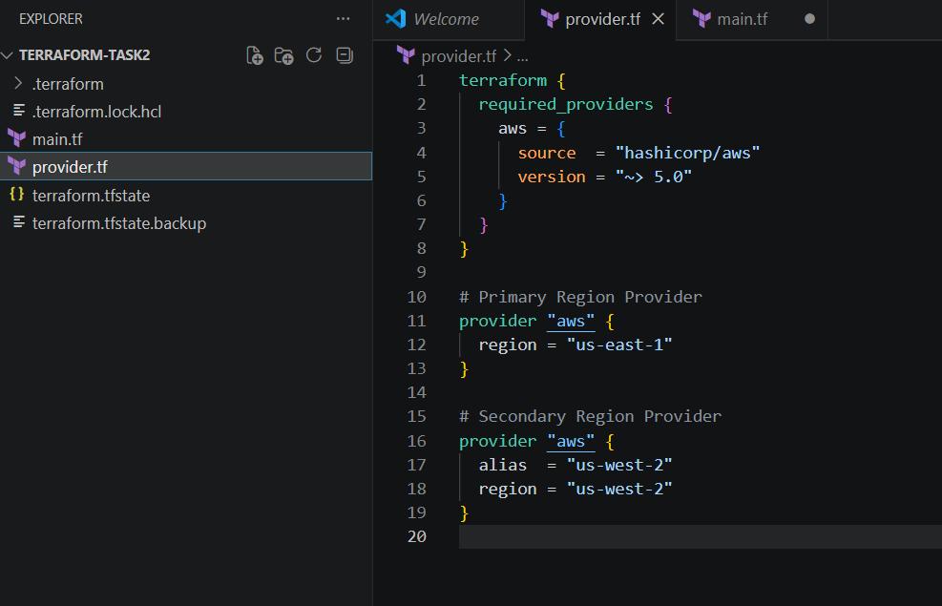

- main.tf
  - 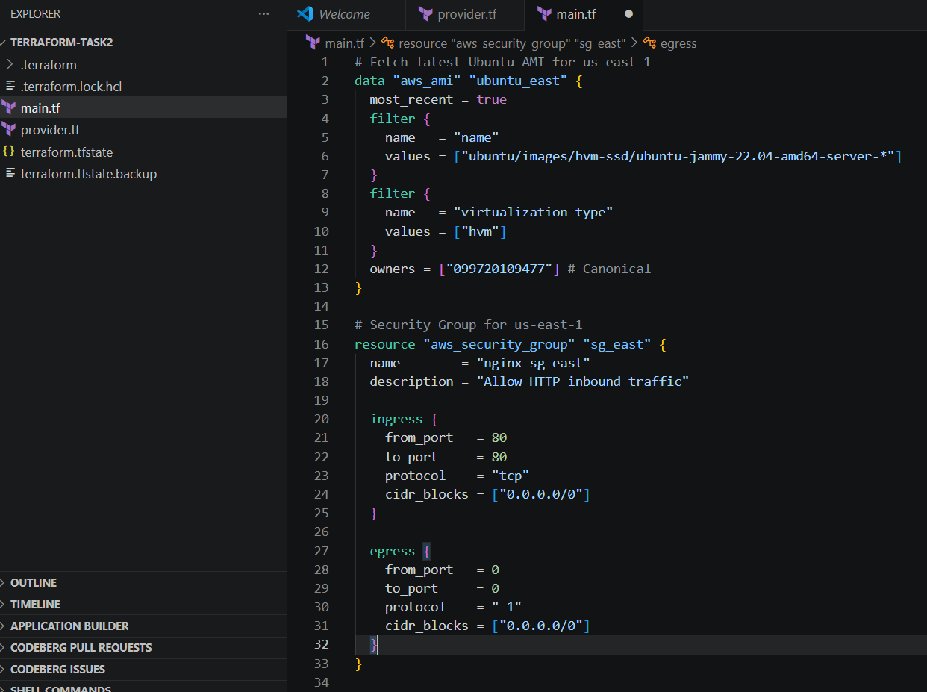
  - 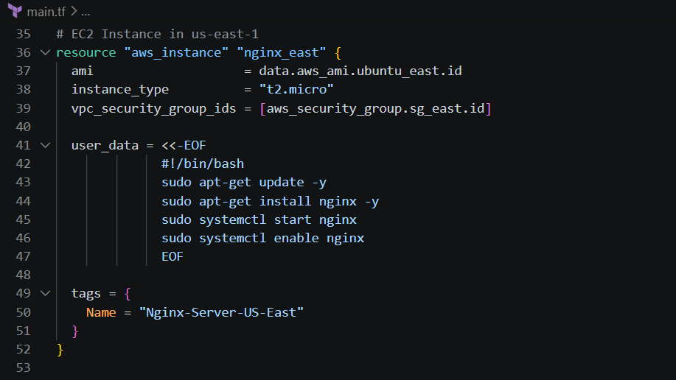
  - 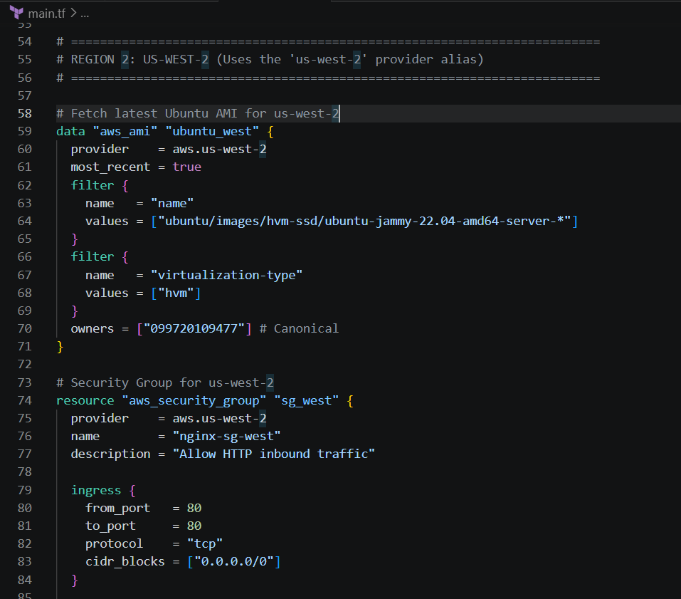
  - 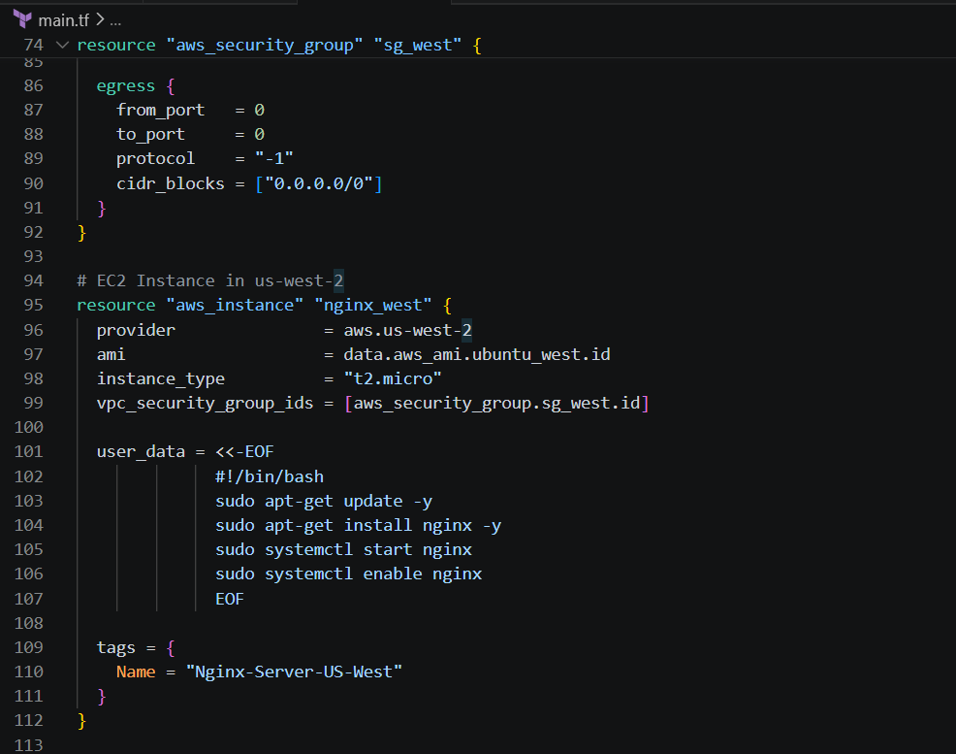
  - 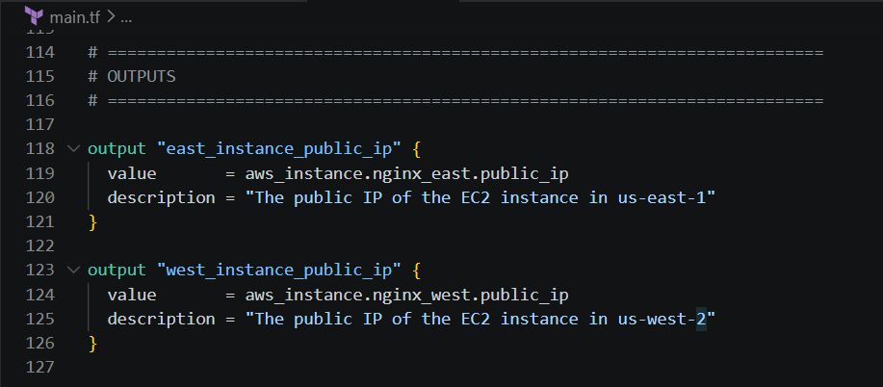
3. Execution Steps
- Initialize the working directory: Downloads the required AWS provider plug-ins.
  - 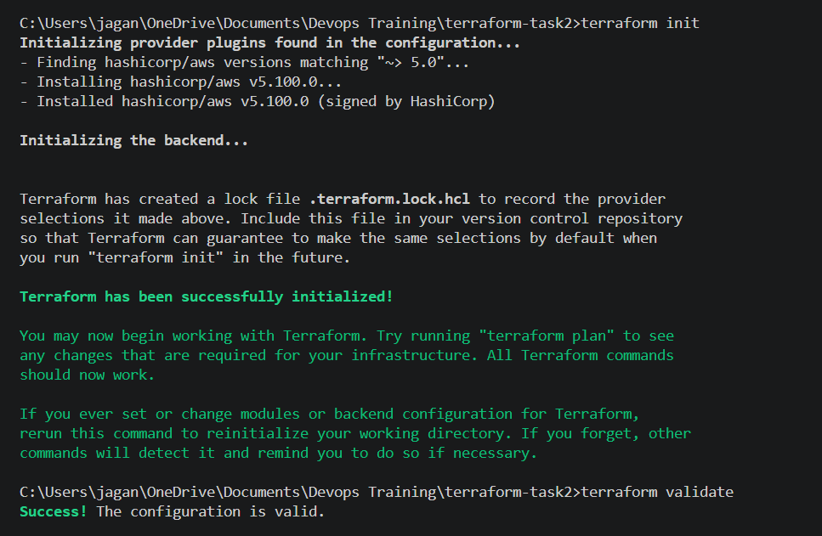

- Review the execution plan: Previews the actions Terraform will perform.
  - 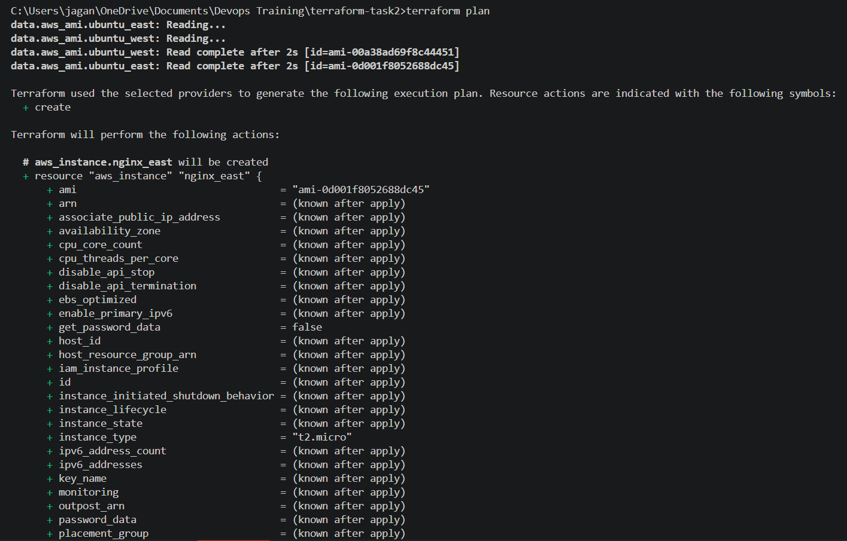
  - 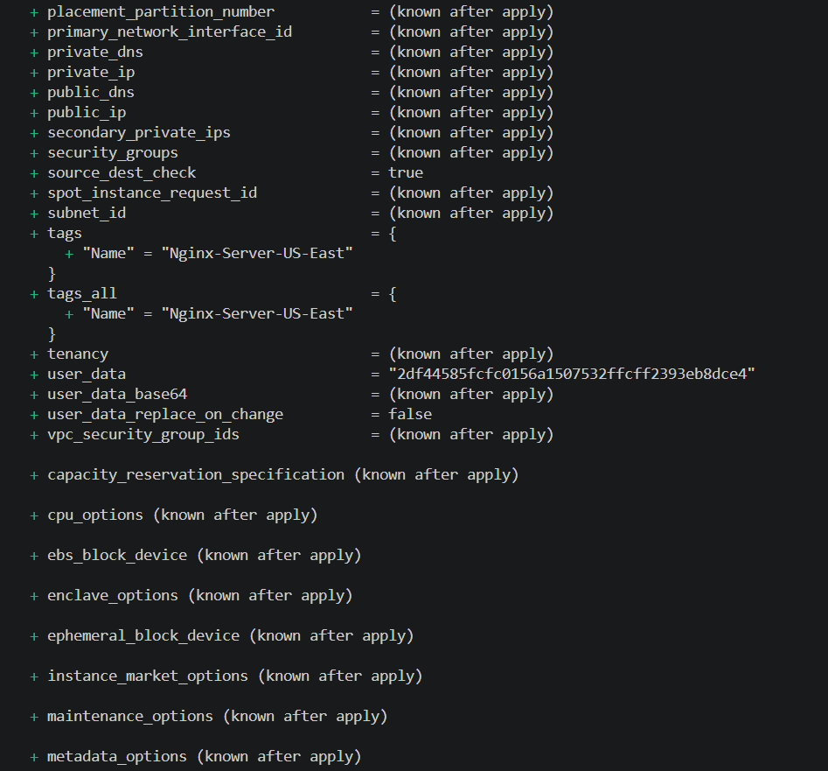
  - 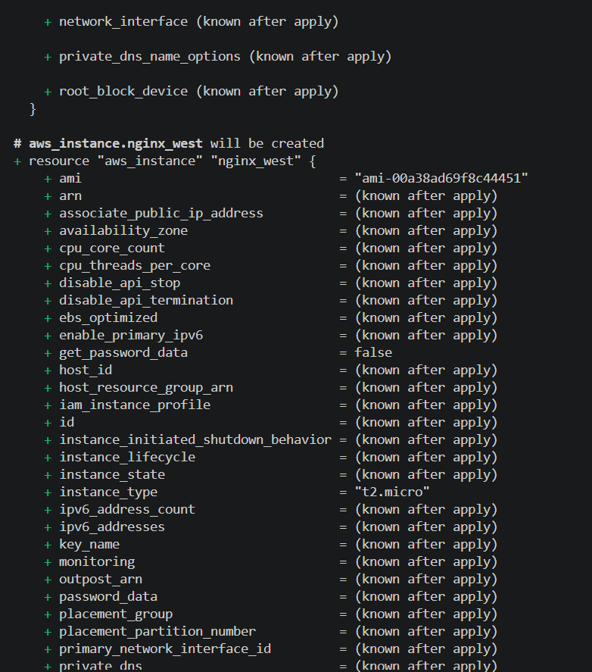
- Apply the configuration: Deploys the infrastructure to AWS.
  - 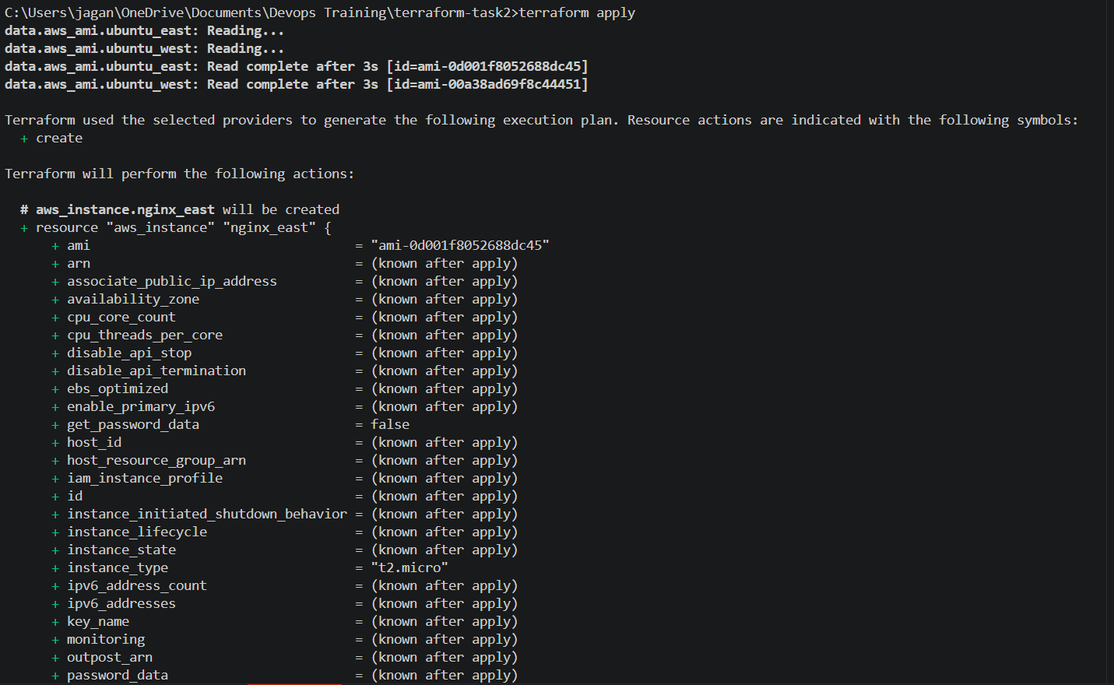
  - 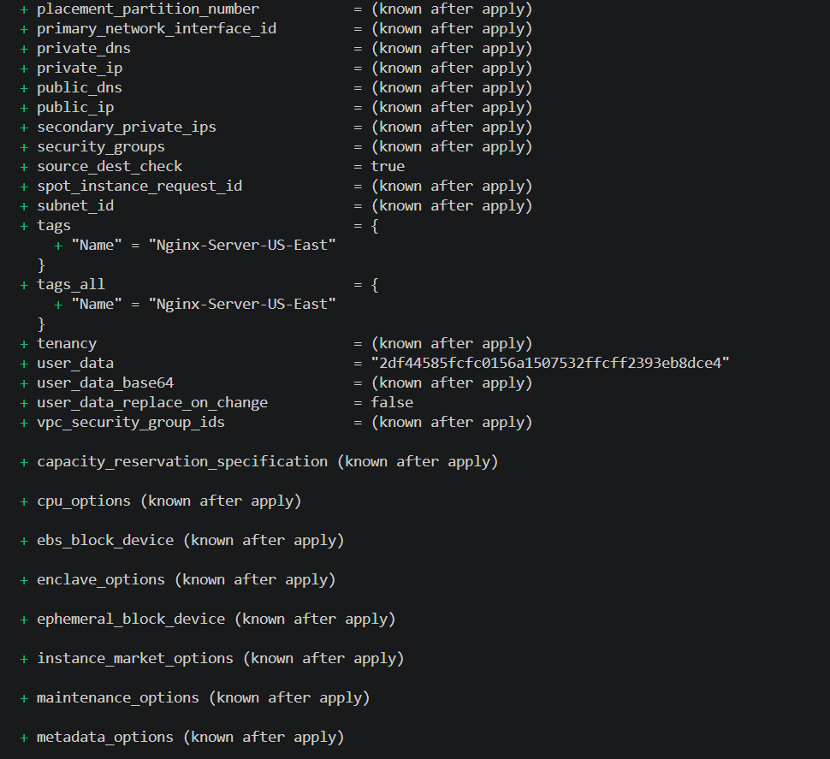
  - 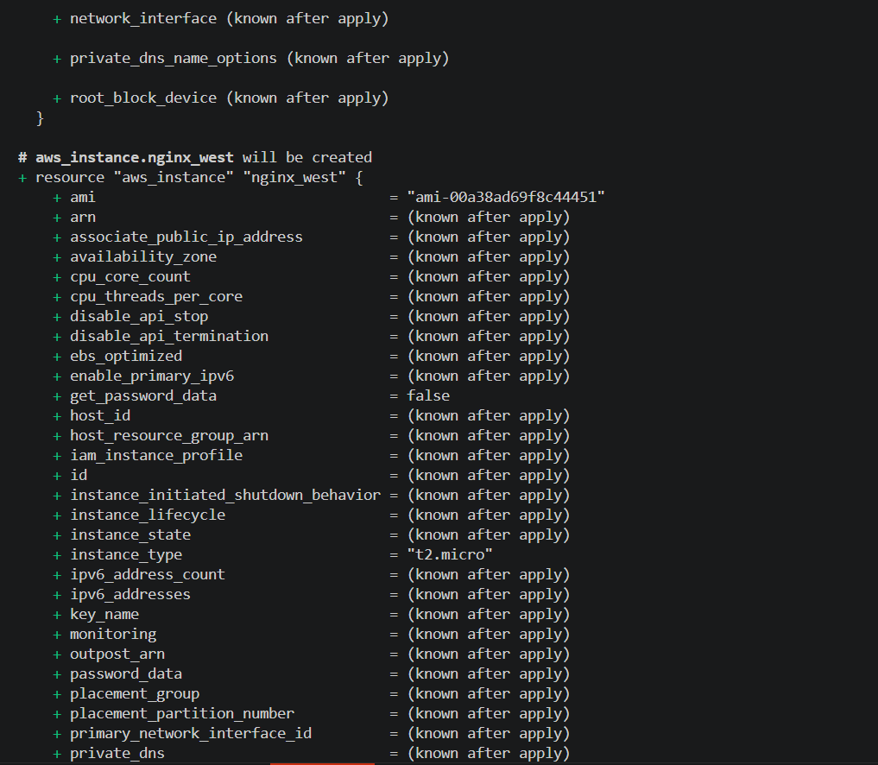
  - 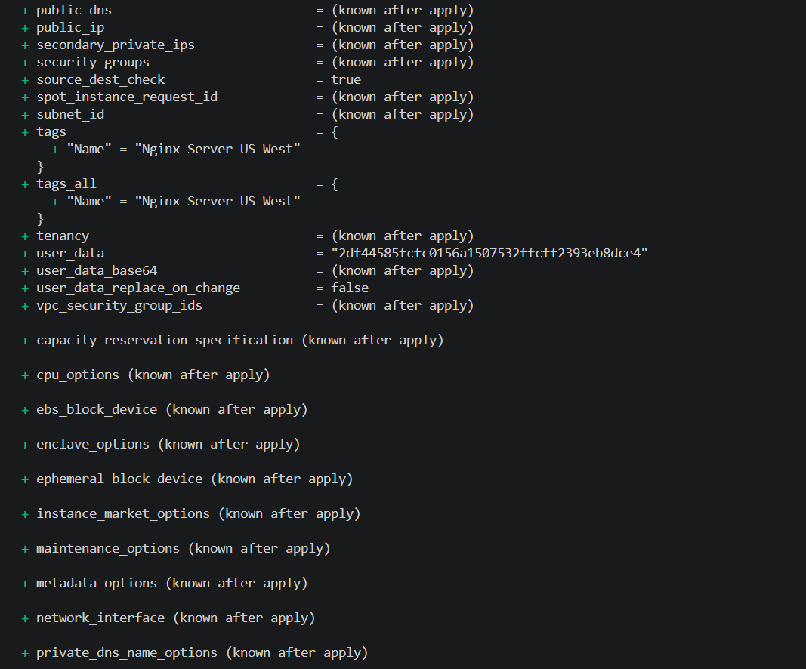
  - 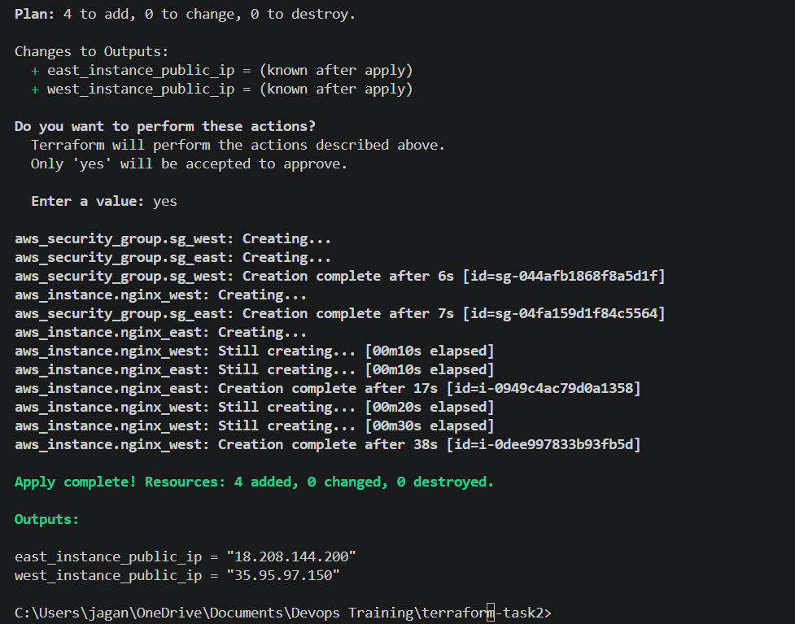

- 4. Verification

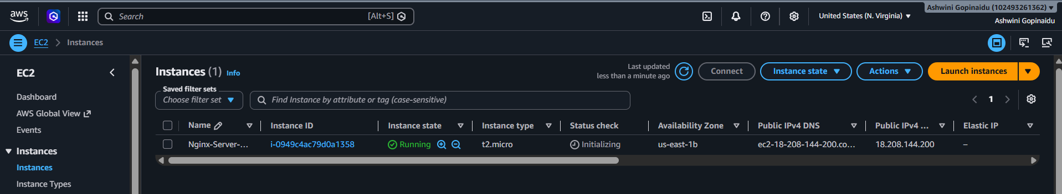

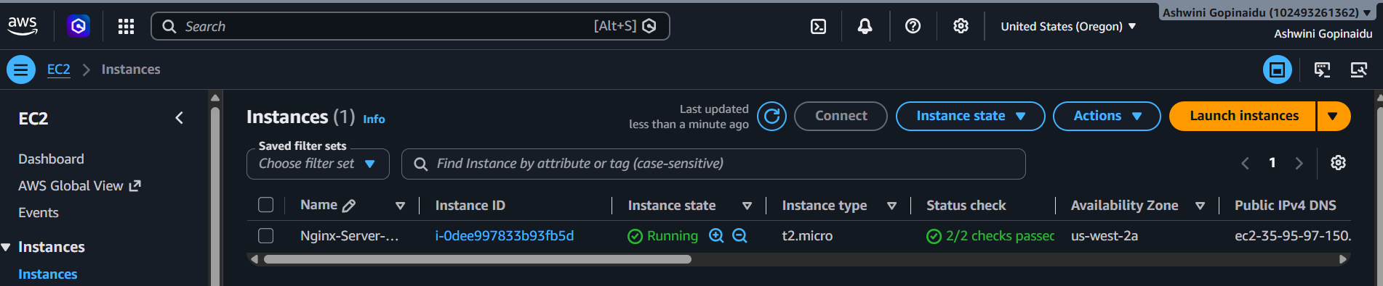

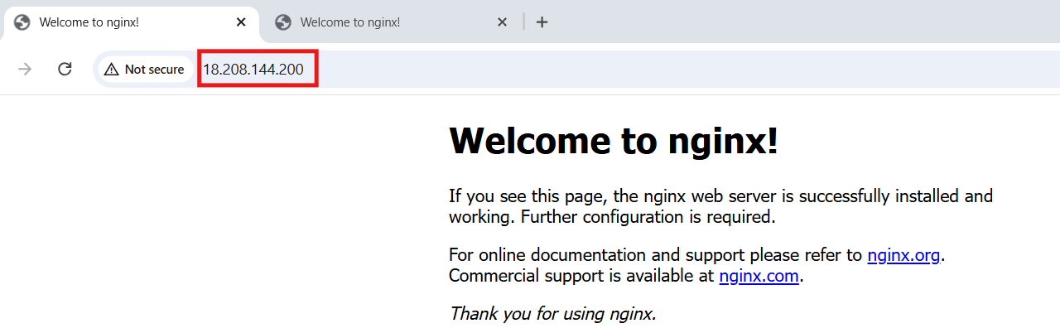

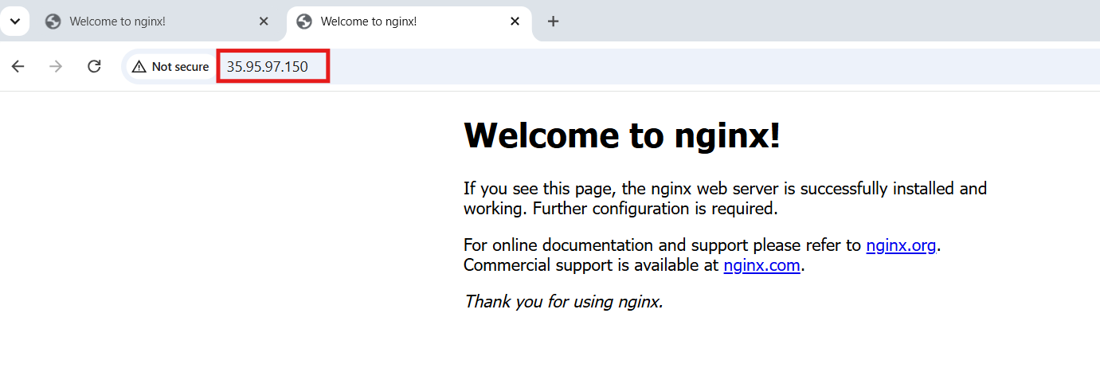

- terraform destroy
  - 